

report

BLOOM

CLOTHING WEBSITE



SUBMITTED BY

Masooma Ali

Fatima Farrukh Rana

submitted to: mam bushra

Table of contents

**Introduction—---------------------------------------------------------------------------------- 2**

**Home page—----------------------------------------------------------------------------------- 3**

**Category page—------------------------------------------------------------------------------ 4**

**Product / functionality page—----------------------------------------------------------- 6**

**Login / Sign up page—--------------------------------------------------------------------- 9**

**Add to cart page—--------------------------------------------------------------------------- 10**

**Payment page—------------------------------------------------------------------------------- 11**

**BLOOM**

**CLOTHING WEBSITE**

This clothing website is made by the collaborative effort of Masooma Ali and Fatima Farukkh Rana. The website was developed by using HTML and CSS. As students, this project provided us the opportunity to apply theoretical knowledge in a real-world context and helped us to learn the fundamentals of web development. We have added basic functionalities in the website.The primary objective was to create a functional and aesthetically pleasing website, serving as a practical learning platform for web development basics. This report includes the description of the HTML and CSS code that we have used to add different functionalities of website and the styling of website.

The website has six pages, three were designed by Fatima and three by Masooma. The pages include Home page , Category page , Products page, Add to Cart page , Login and Sign up page , Payment page.

**HOME PAGE**

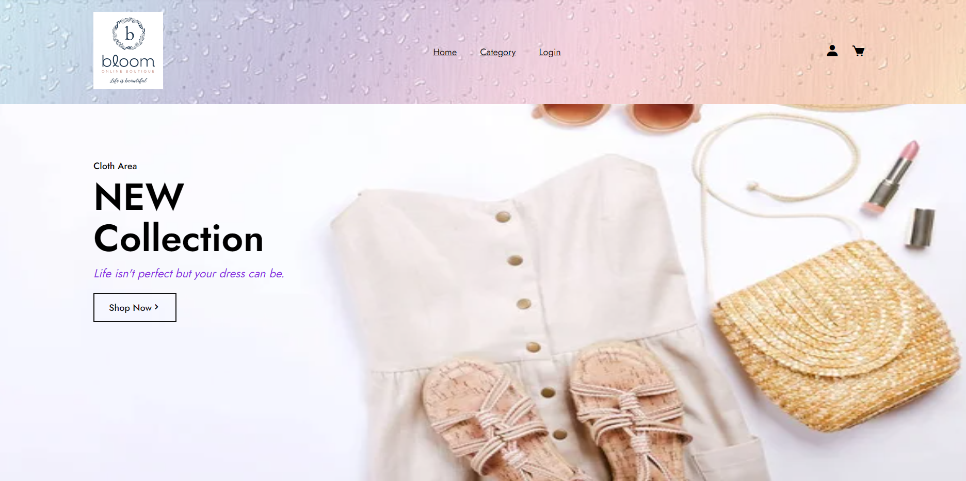

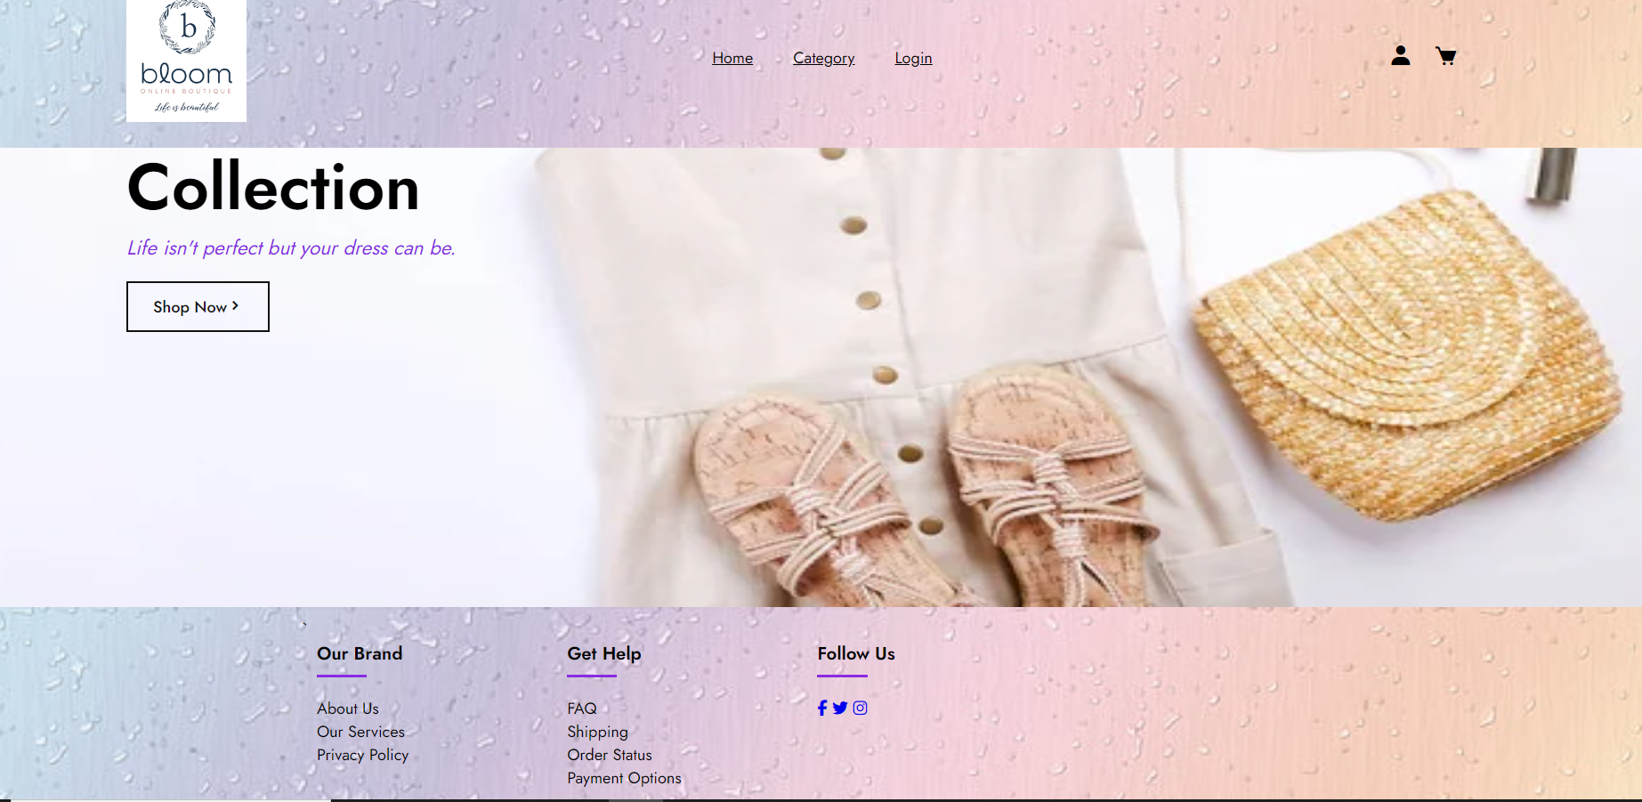

This is the home page of website. I have included the same header and footer to all the pages. This page is main so all other pages are linked with this page. The button in header, category and login, willdirect the page towards the respective page. The login and cart icon is also linked with the login and add to cart page. In footer I have included necessary details about the website and also added social media icons. The Shop Now button is linking the home page with the category page.

**Category Page**

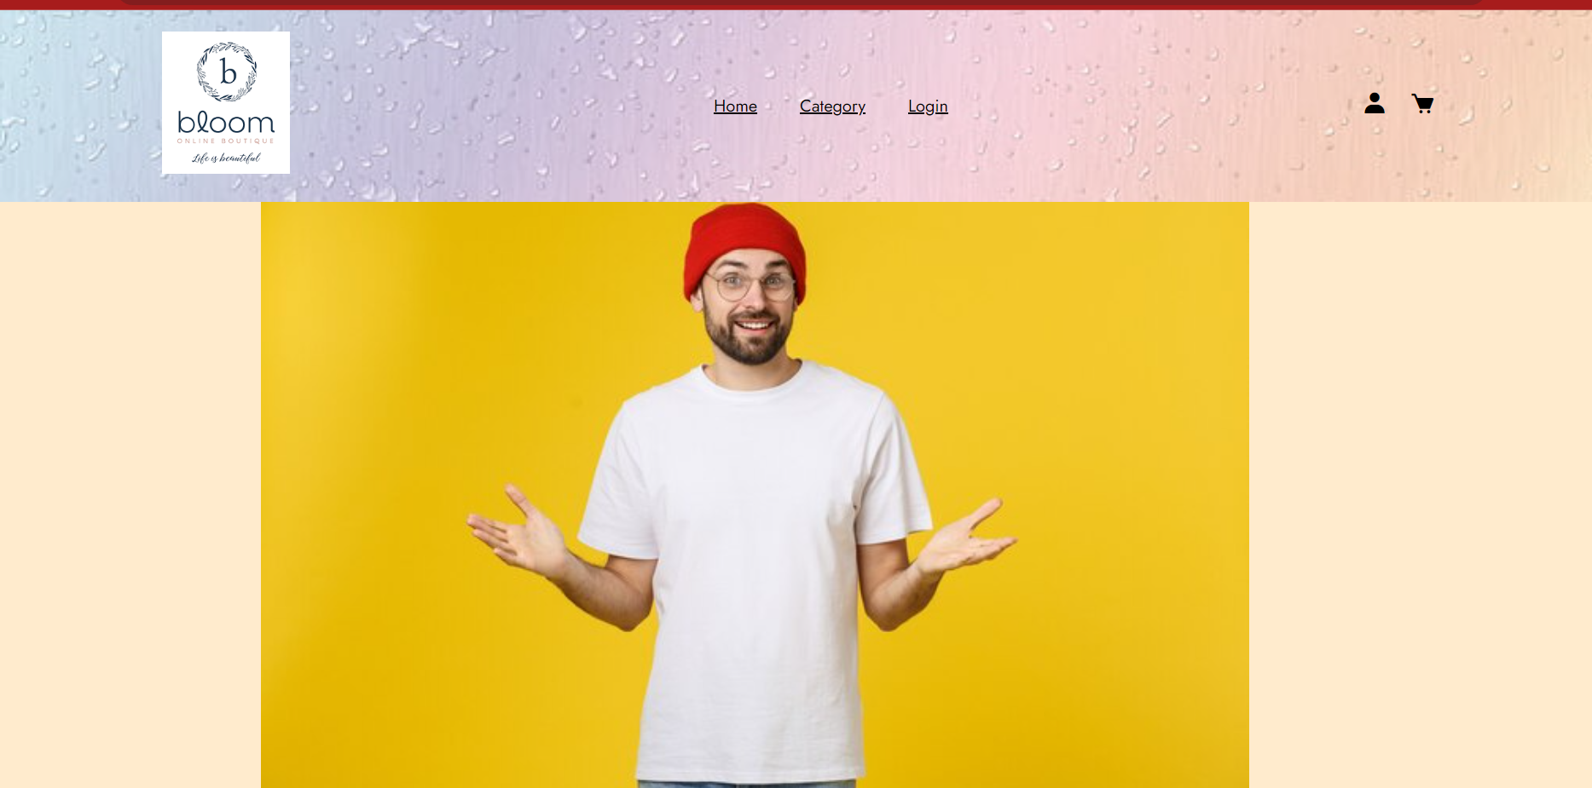

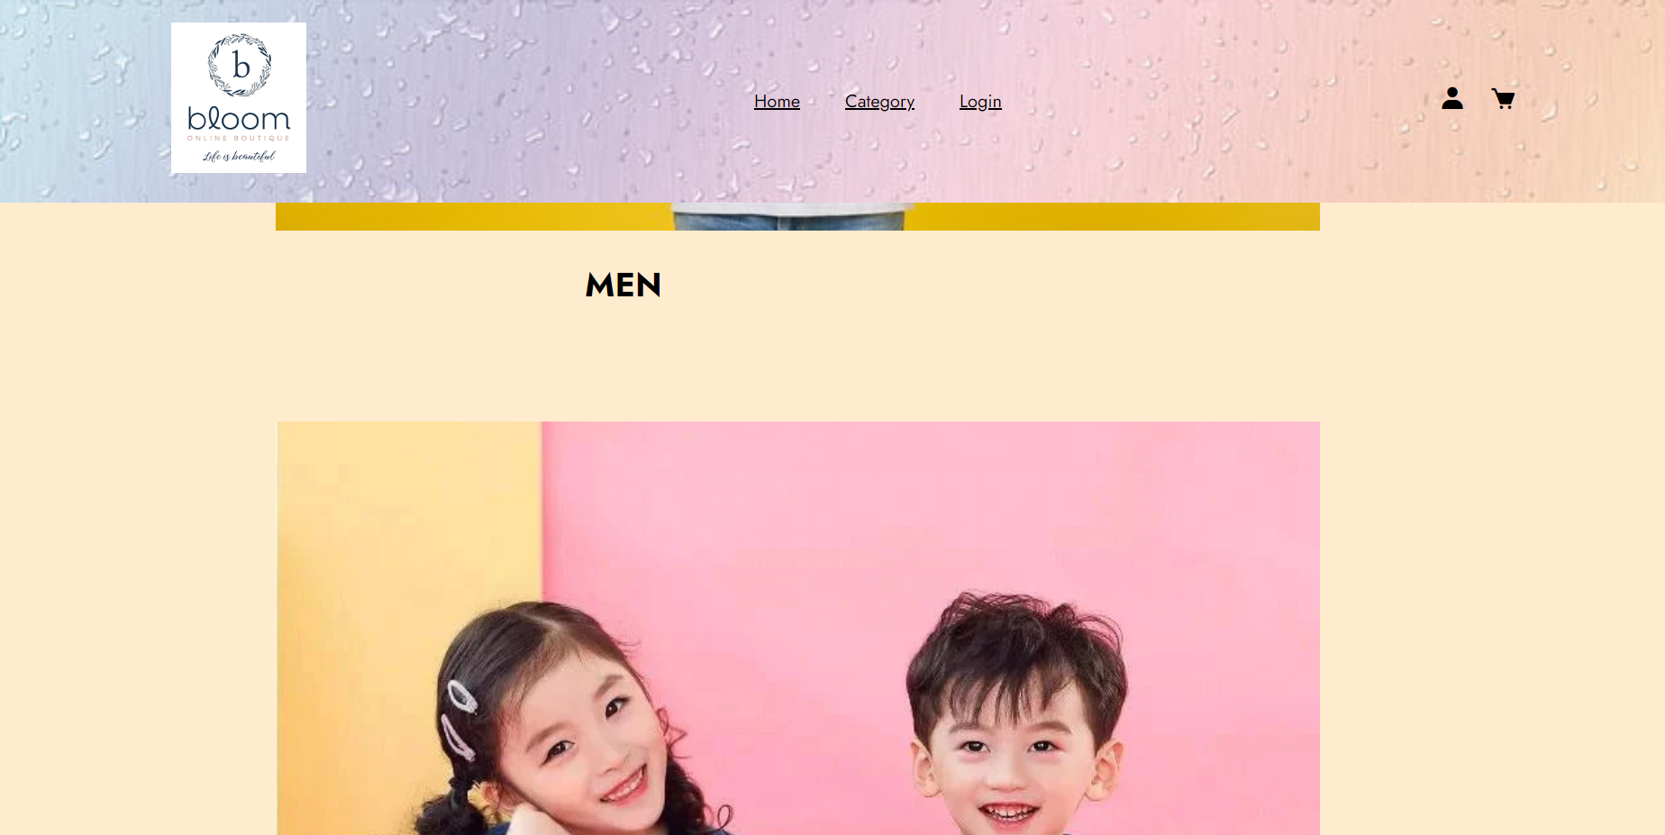

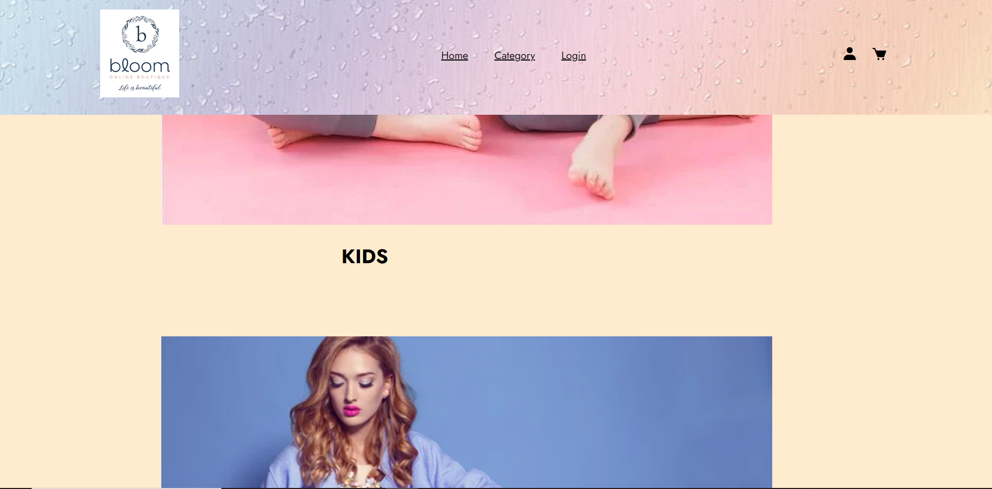

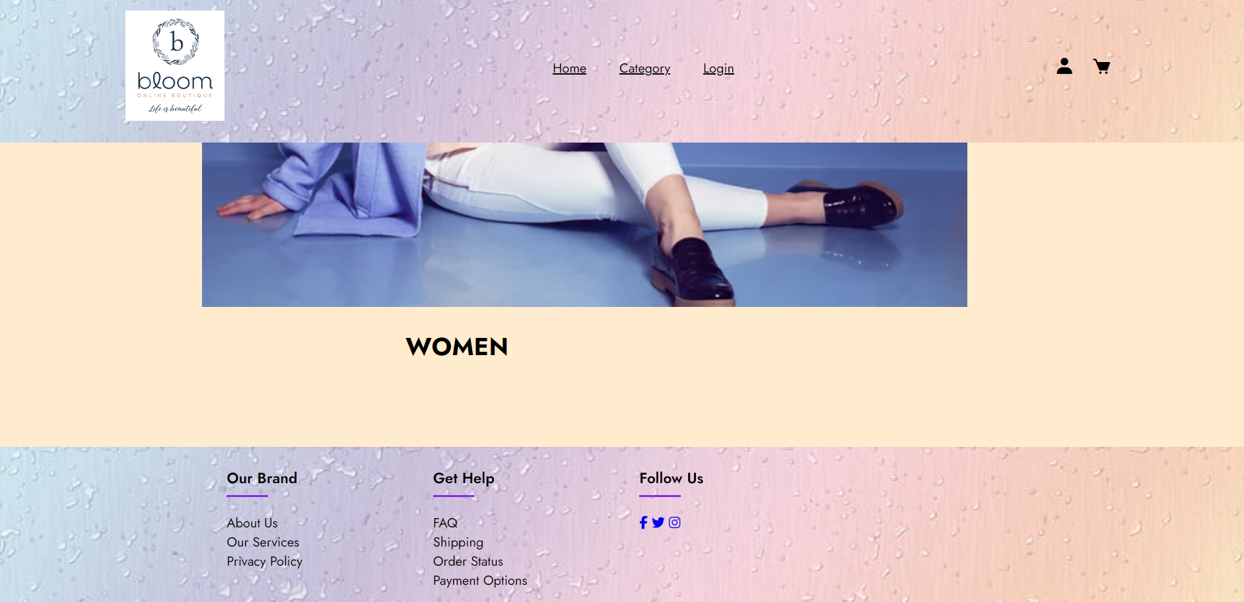

The next page is category page. Same header and footer is used in this page as well and have same functionality as the one in home page. Here i added three categories Men , Kids , Women. On clicking them this page is directed towards the product functionality page.

For the navigation and easy transition between pages icons and buttons are used in the header like the cart icon and buttons like home, category and login when these are clicked they will direct towards the respective page.

**Products / Functionality Page**

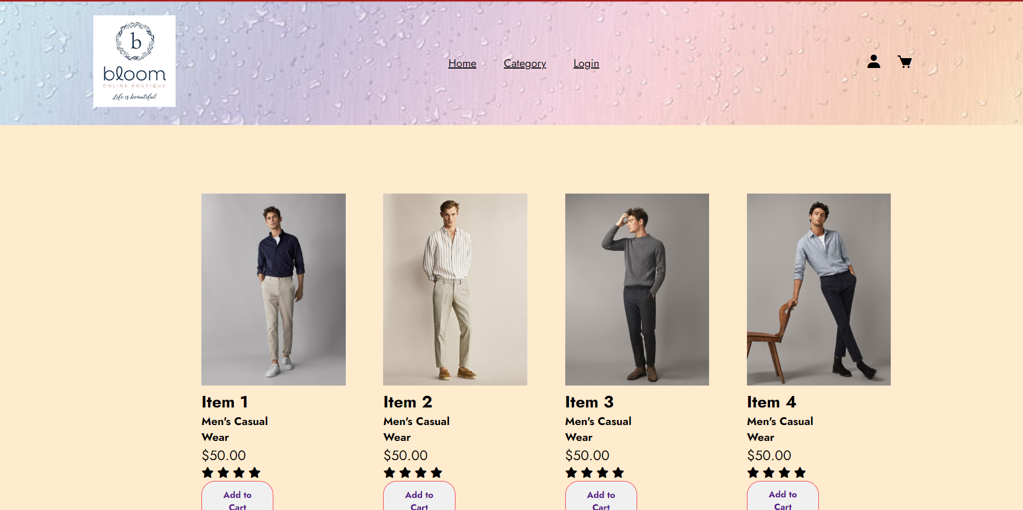

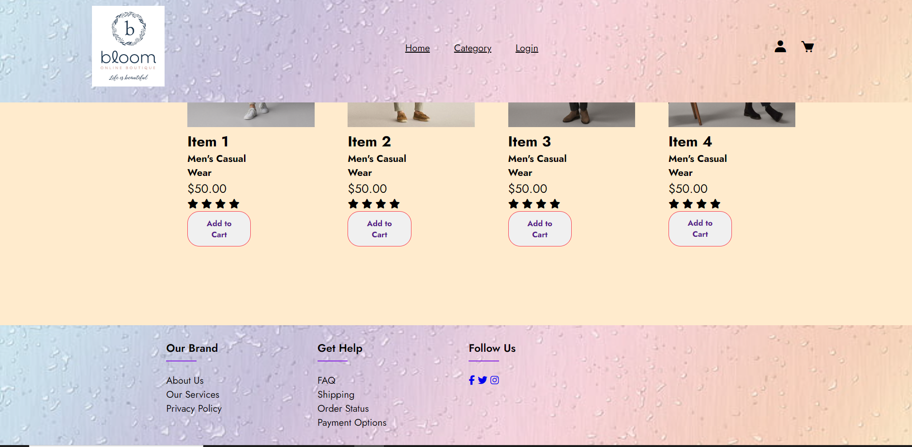

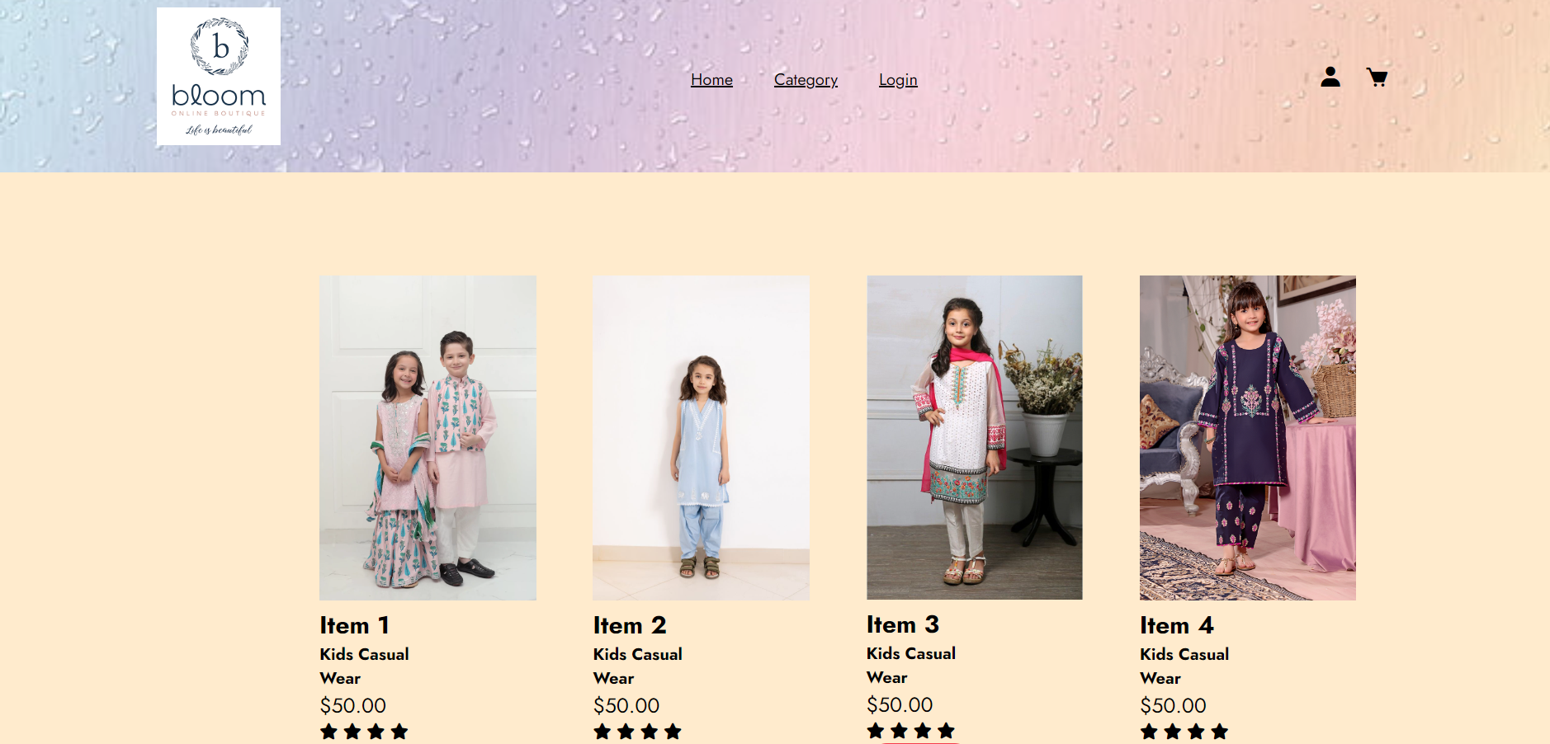

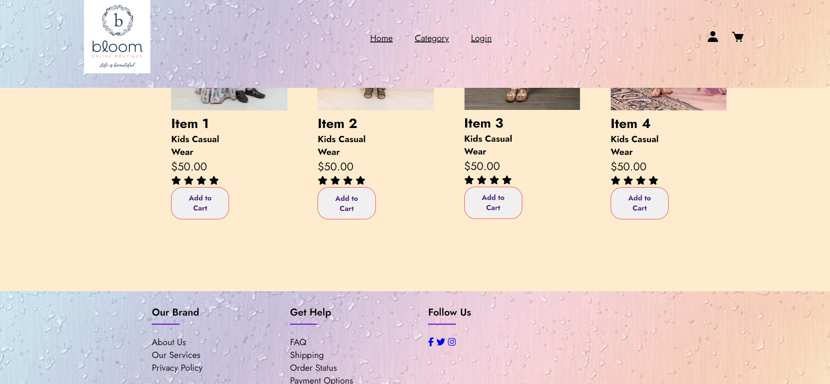

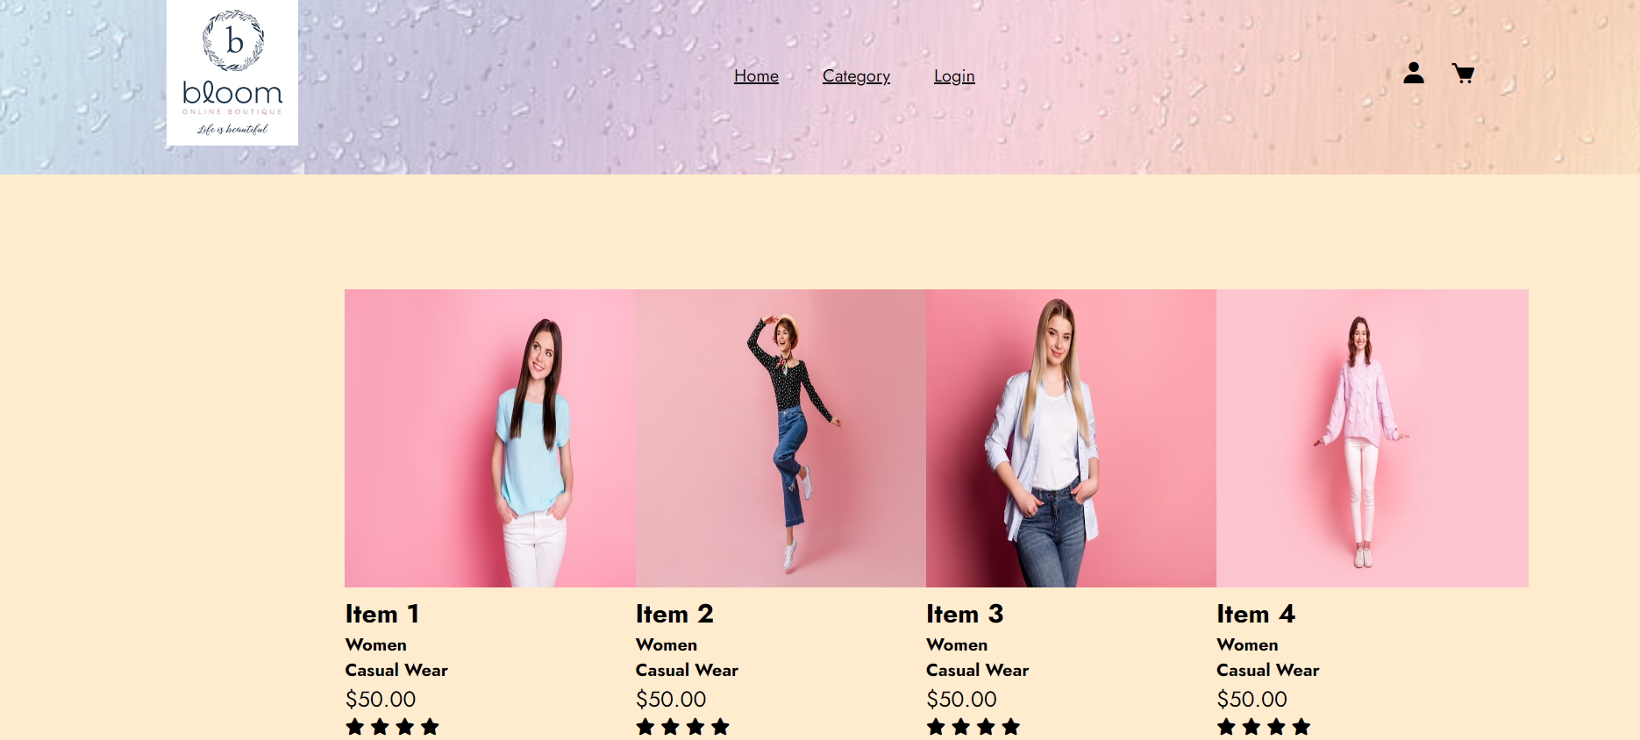

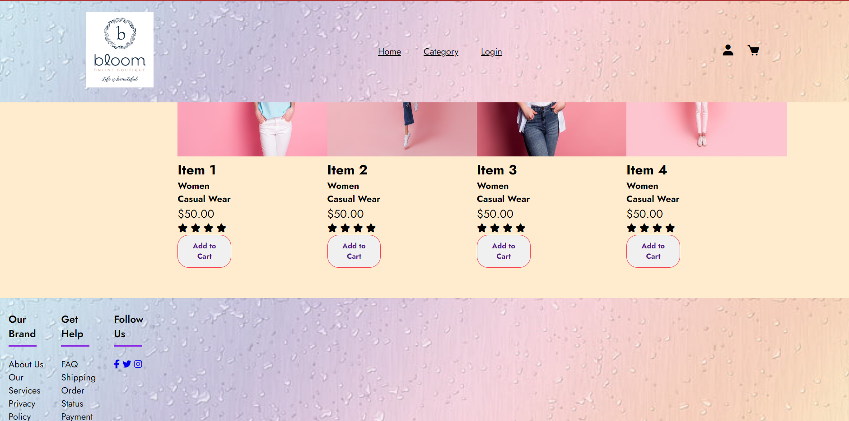

This is the product functionality page and it was linked with the category page. After selecting one of the categories, products related to that category is displayed. In this add to cart button is added to providing the functionality of buying the products but Java script was not allowed so static add to cart is made in which the same products will be shown every time when clicked on add to cart. Also some description about the products is added. You can return to category page by clicking on category written on header. The same header and footer is used and have the same functionality as the previous ones.

**The login Page**

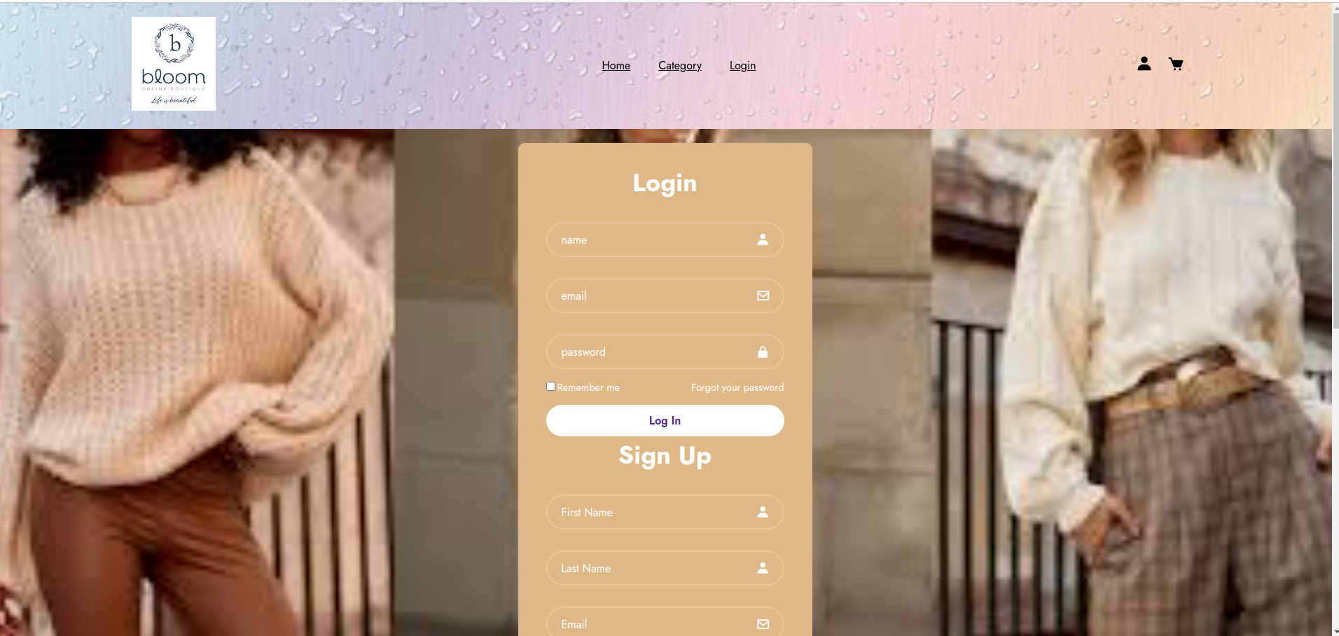

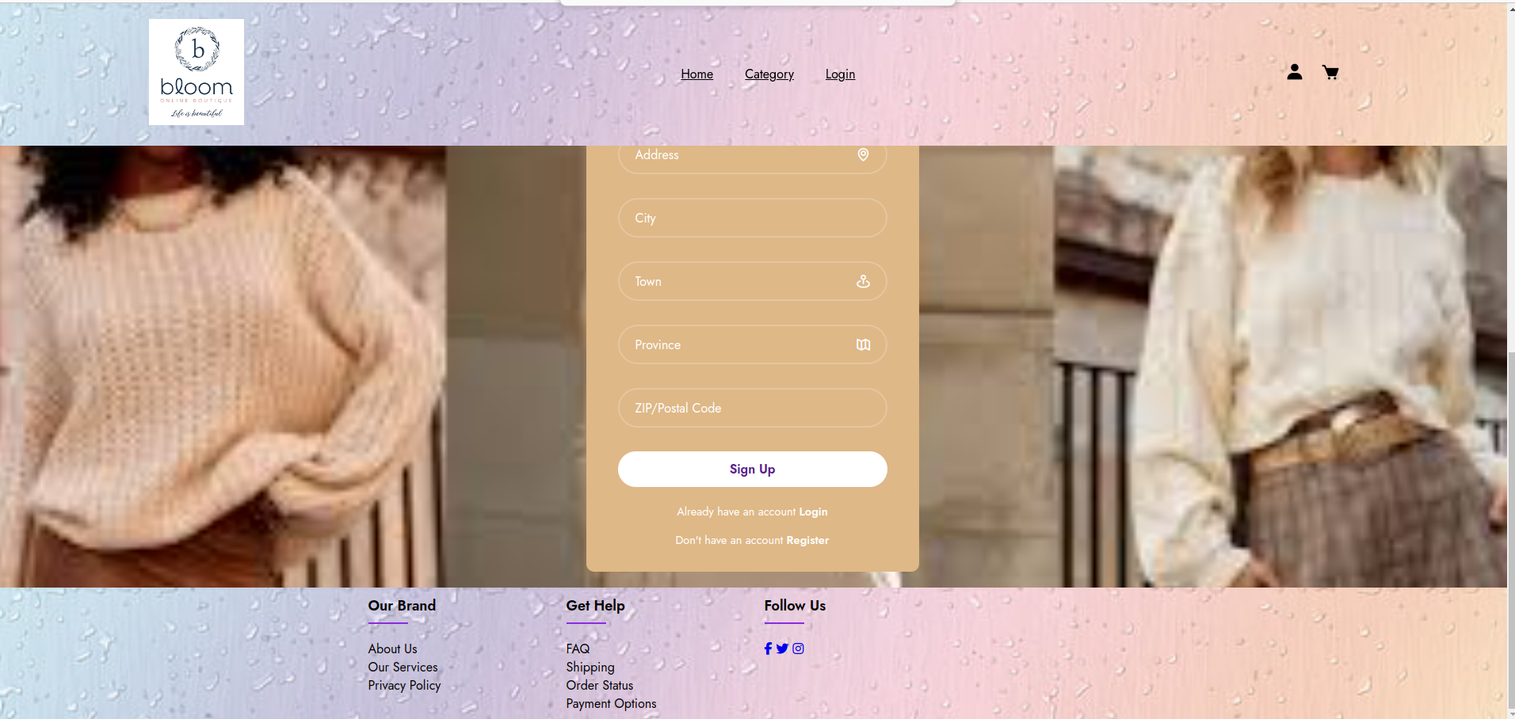

The page contains header and footer like the previous pages.Navigation links include home,category and login and there are buttons present for user interaction that lead to this login page and the cart as well.The main content is wrapped in a <div class="wrapper"> to organize the layout.Inside the wrapper there are two forms one for wrapper one for sign up.The login form has input for name, email and password and submitting the form leads to the main home page. There is a remember me box and a forget password box as well.Then comes the sign up form that includes fields for first name last name name email password city and zip code.It has a sign up button that leads to home page when clicked.Styles are applied to enhance the appearance of the page.The forms are styled with border radius ,shadows and spacing.User can navigate through different sections using links in header.This form is designed for user authentication.Overall, this code creates a user-friendly webpage with a responsive design for login and signup functionality, along with navigation and social media links in the footer.

**The Cart Page**

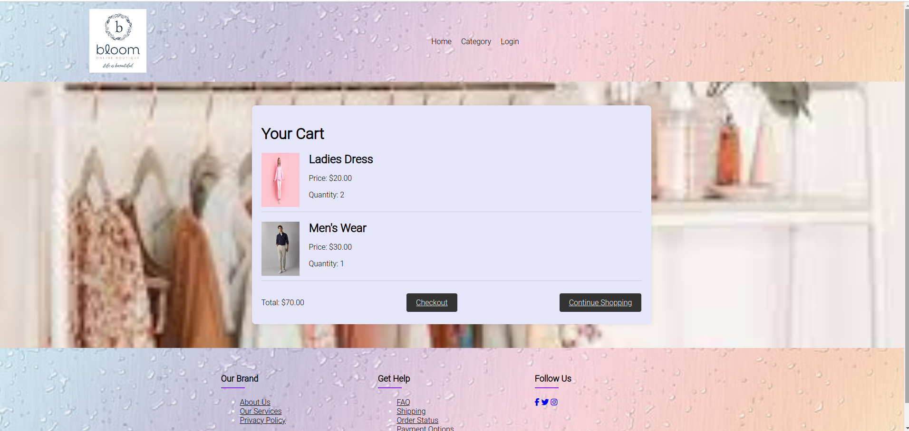

A container (<div class="cart-container">) holds the cart-related content.

Cart items are displayed, each with an image, product details (name, price, quantity), and two sample items are shown.The total price of two objects is displayed.The div class cart container serves as a container for entire cart related content.A heading you cart is displayed at top of cart.Two cart items are displayed, each enclosed within a <div class="cart-item">.Each cart item consists of an image (<img>), product details (<h2> for the name, <p> for price and quantity), and a nested <div class="item-details"> for better styling.

* The total price of the items in the cart is displayed using <p>Total: $70.00</p>.
* Two buttons are provided:
  + <a href="payment.html" class="btn">Checkout</a>: This button links to a payment page and is styled as a button with the class "btn."
  + <a href="category.html" class="btn">Continue Shopping</a>: This button links to the category page, allowing users to continue shopping.

Overall, this section creates a visually appealing and informative representation of the items in the shopping cart, including their details and total price. Users can easily proceed to checkout or continue shopping with the provided buttons.

**The Payment Page**

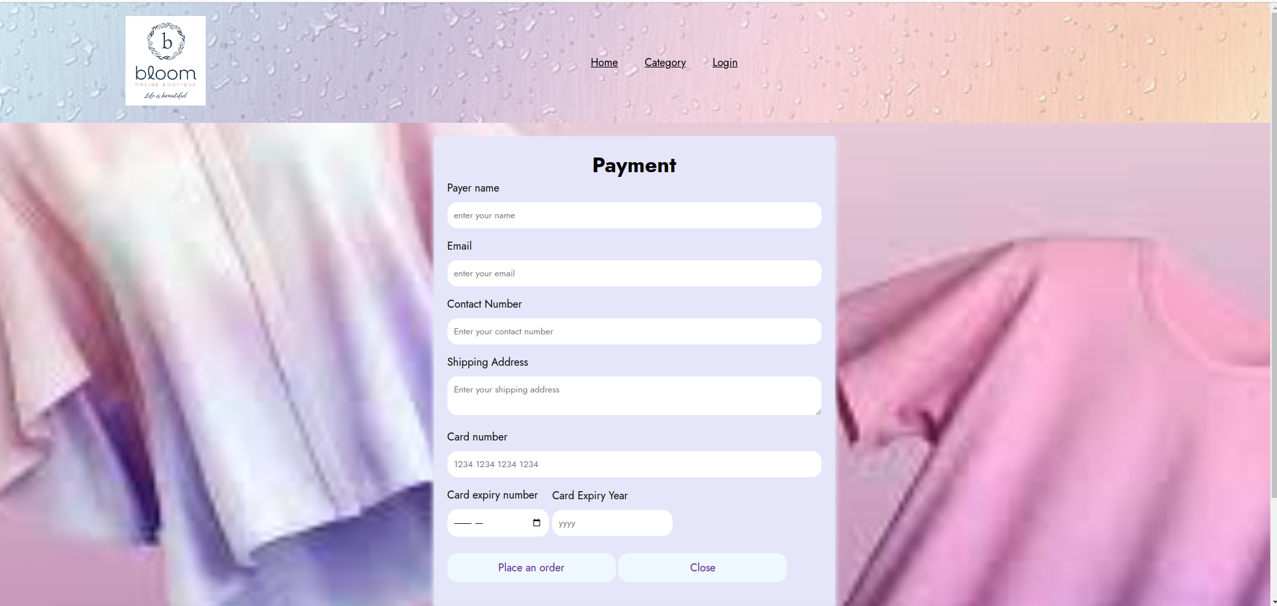

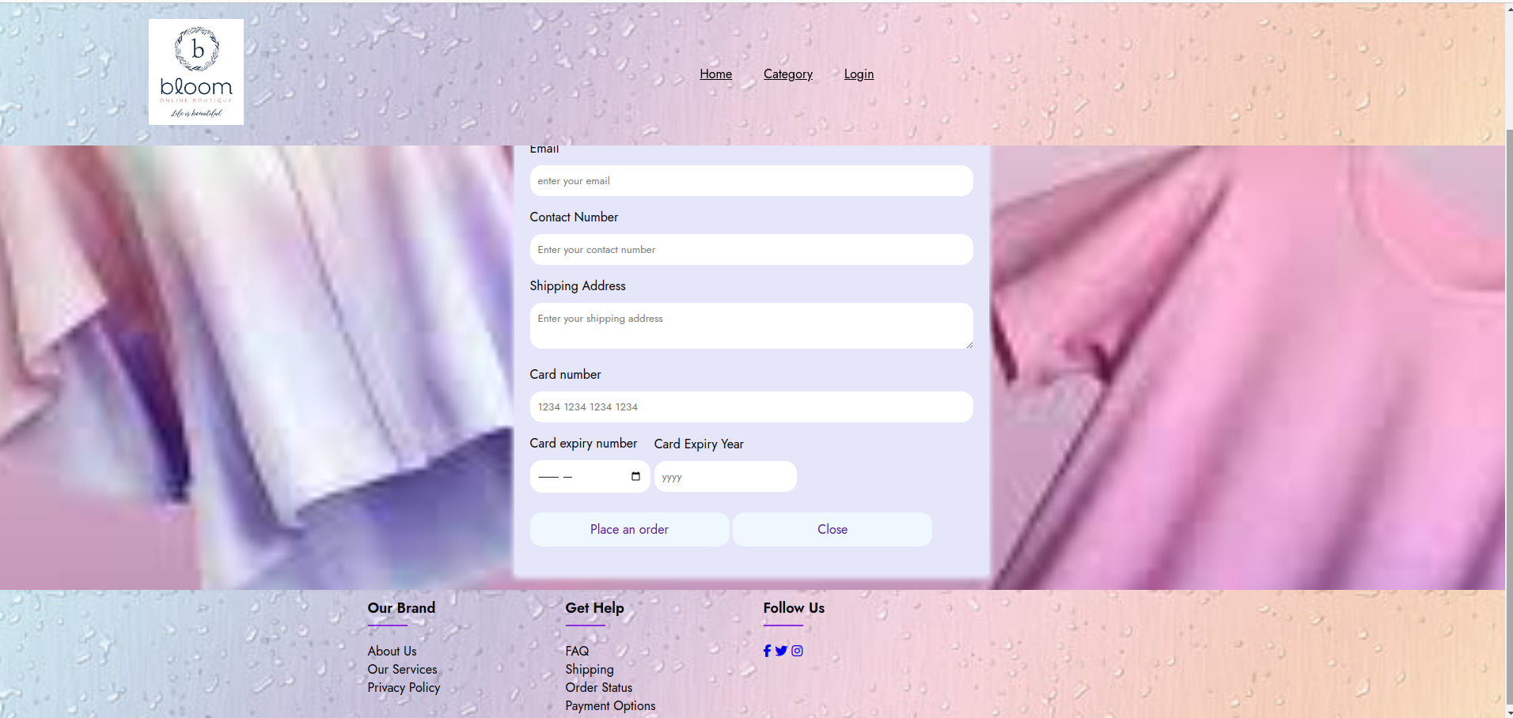

In this page the form action=action sets up a form to collect user information for payment.The form has a heading as payment.Each <label> tag provides a label for the corresponding input field, making the form more user-friendly.Input fields (<input>) are used for the payer's name, email, contact number, shipping address, and card number.Two <div> elements are used to group the input fields for card expiry month and year.<input> with type="month" allows the user to select the card expiry month.<input> with type="year" allows the user to enter the card expiry year.

Two buttons are provided at the end of the form.

* <a href="website.html" class="btn">Place an order</a>: This is a button that, when clicked, could trigger the submission of the form to complete the payment.
* <a href="website.html" class="btn">Close</a>: This is a button that, when clicked, could close the payment form.

In summary, this payment form collects essential information for a transaction, such as the payer's details and card information. The buttons at the end suggest actions the user can take, such as placing an order or closing the form.